SIMPLE DECISION TREES
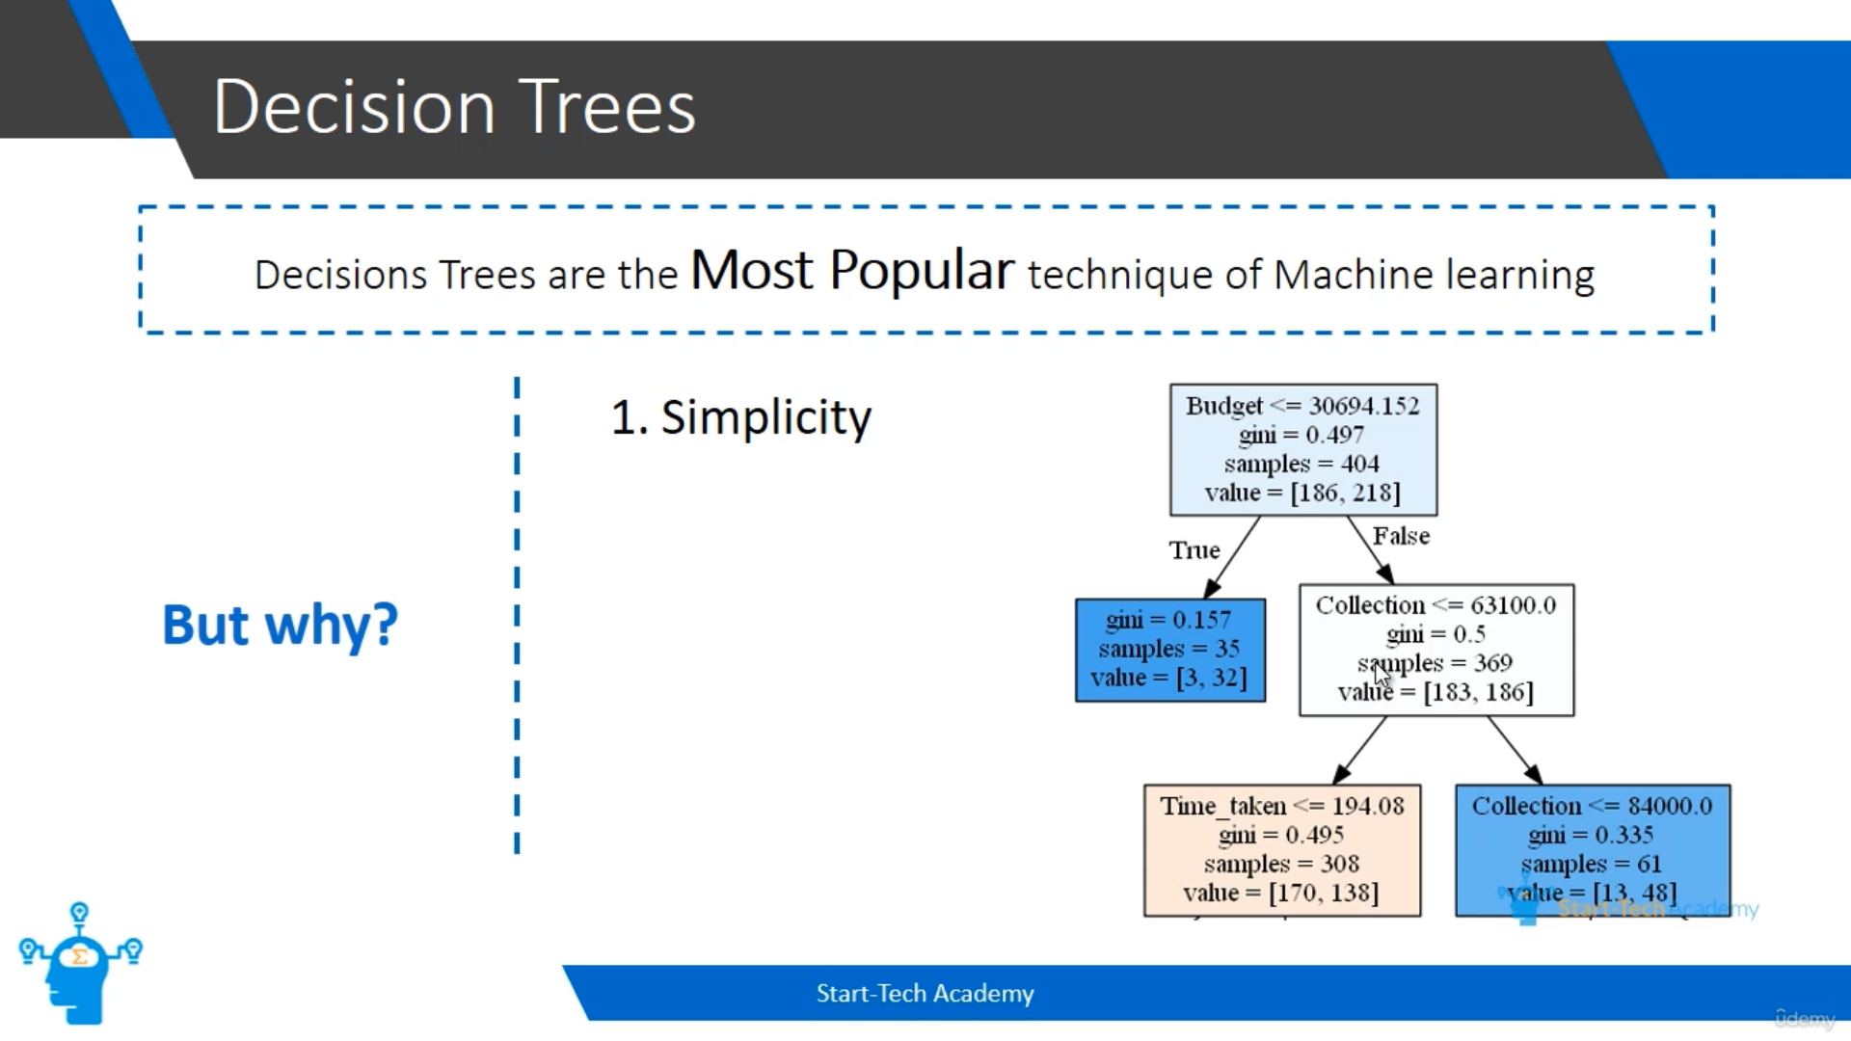
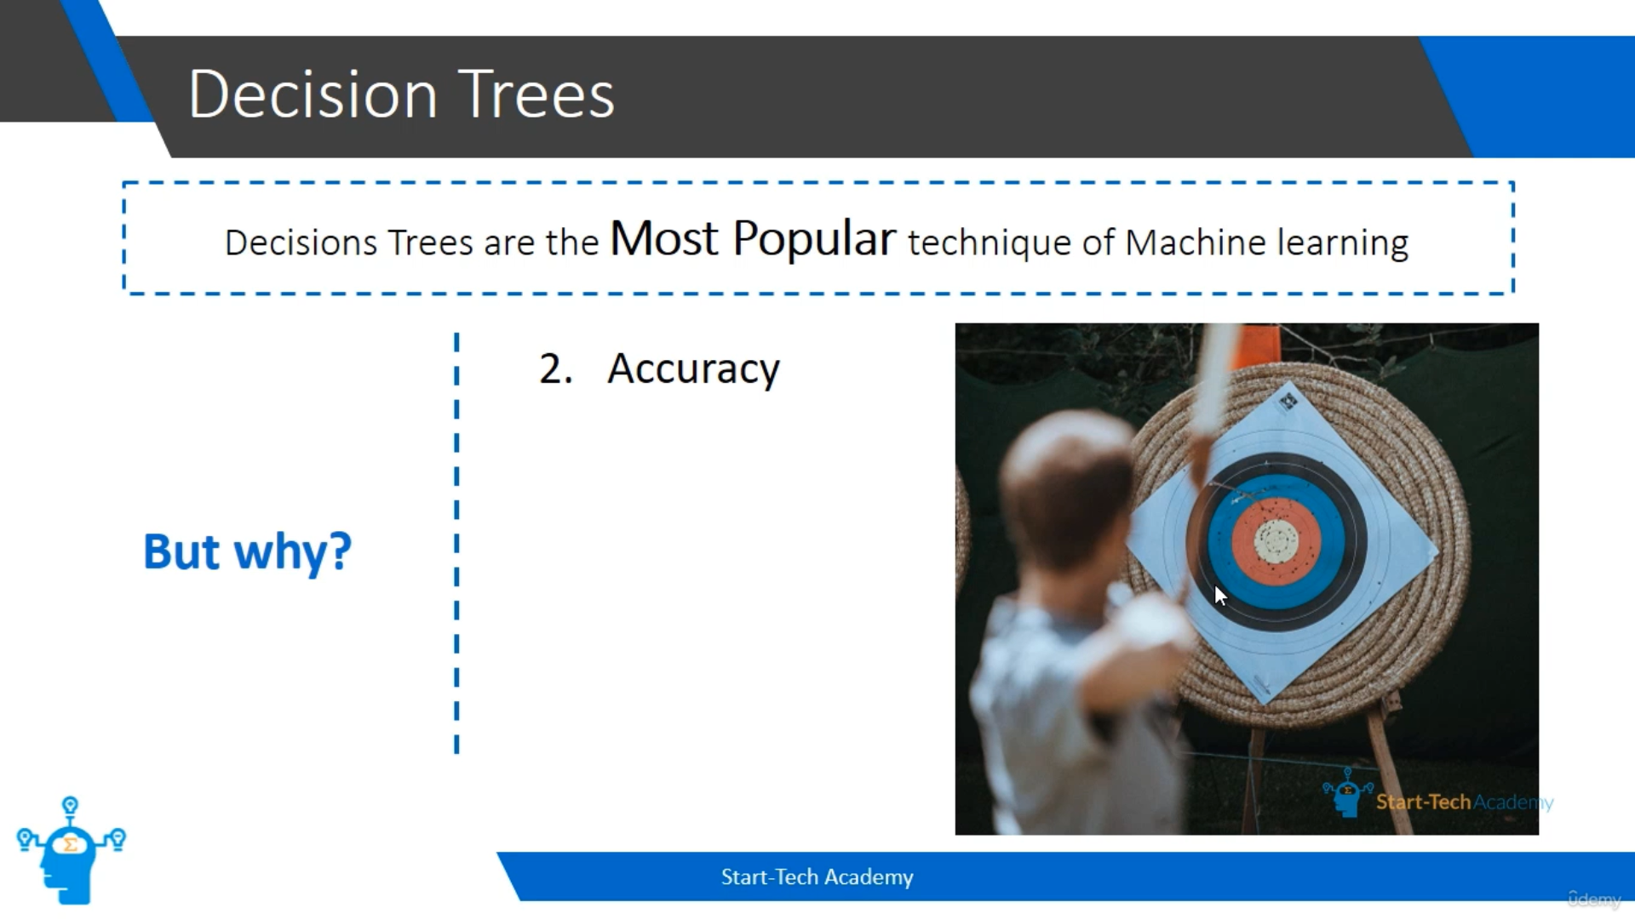
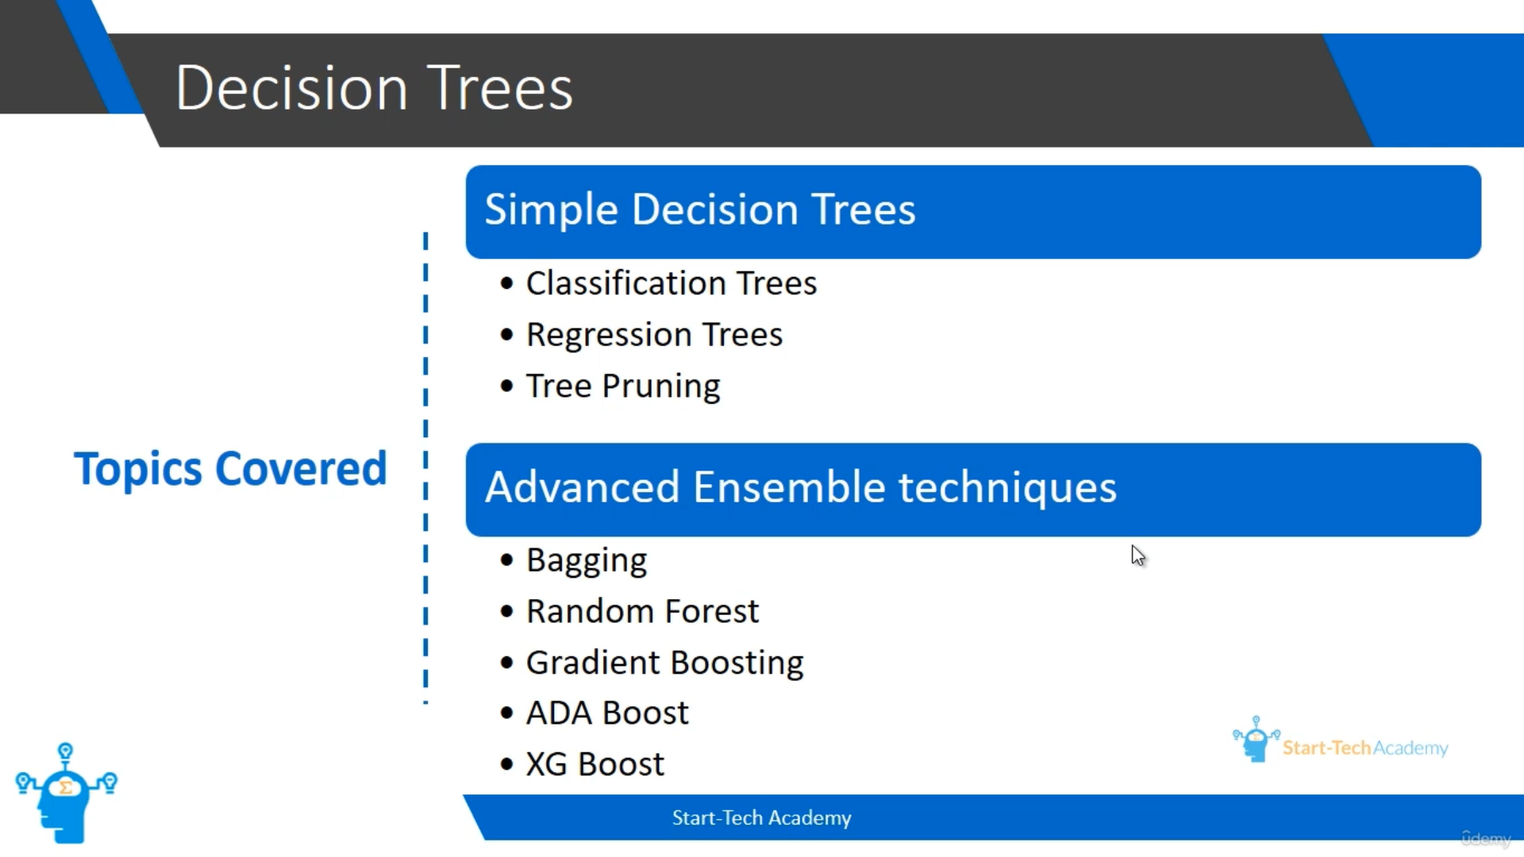
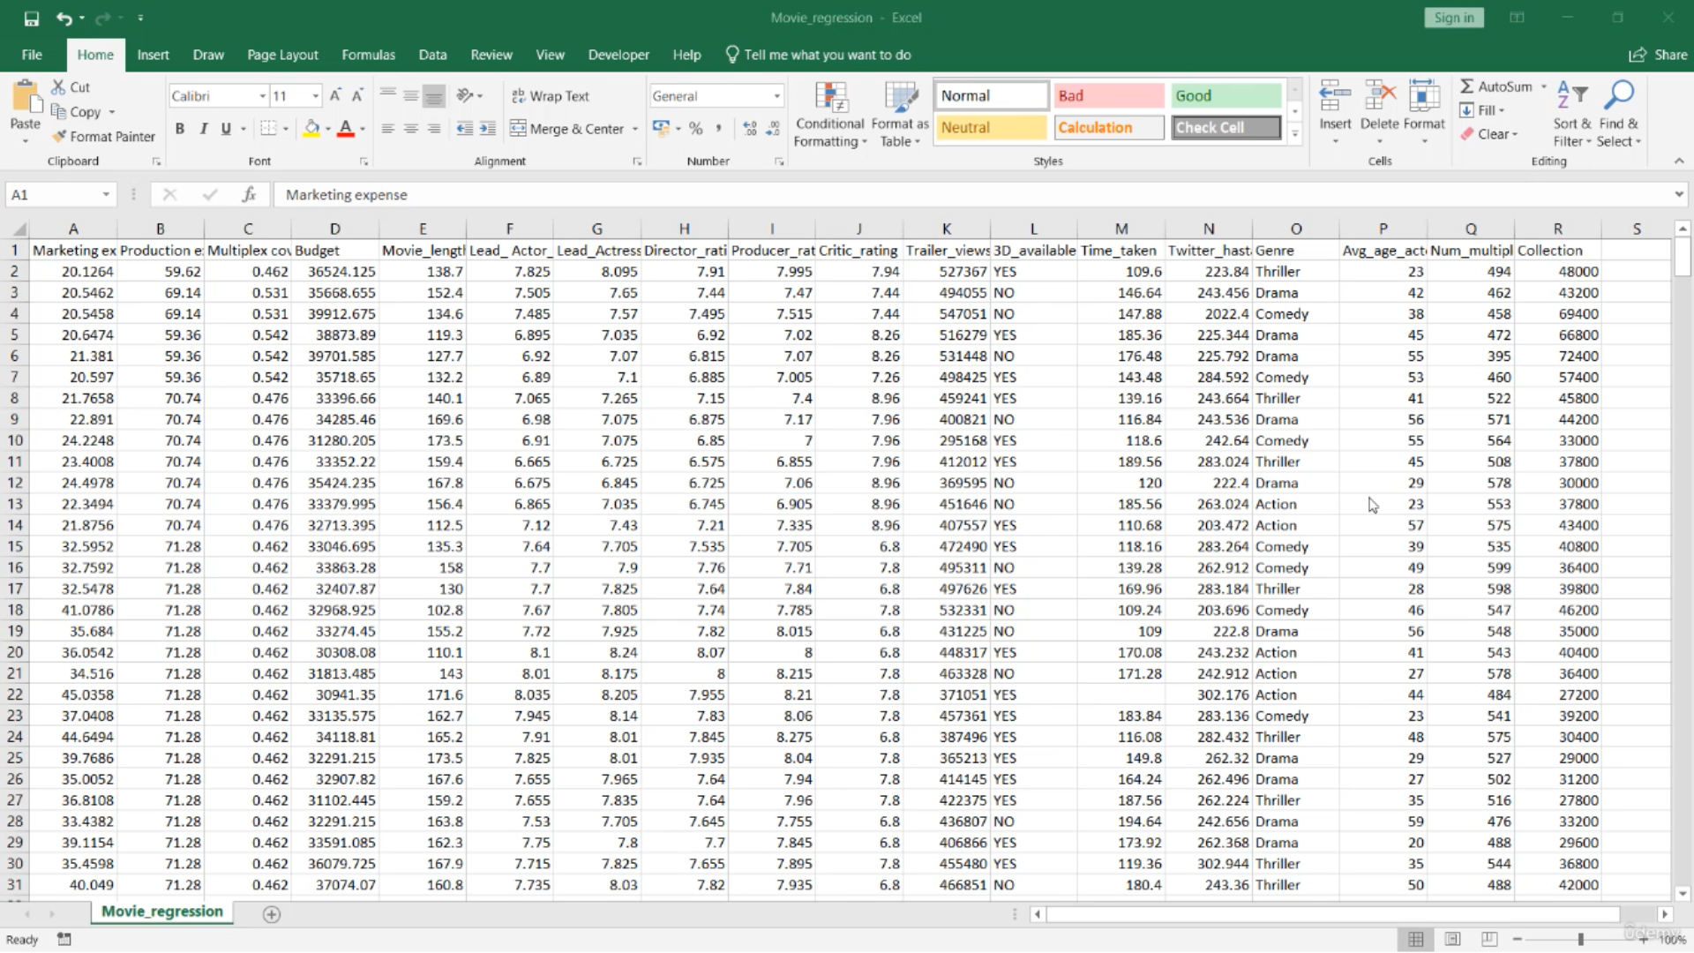

What is Decision Tree?
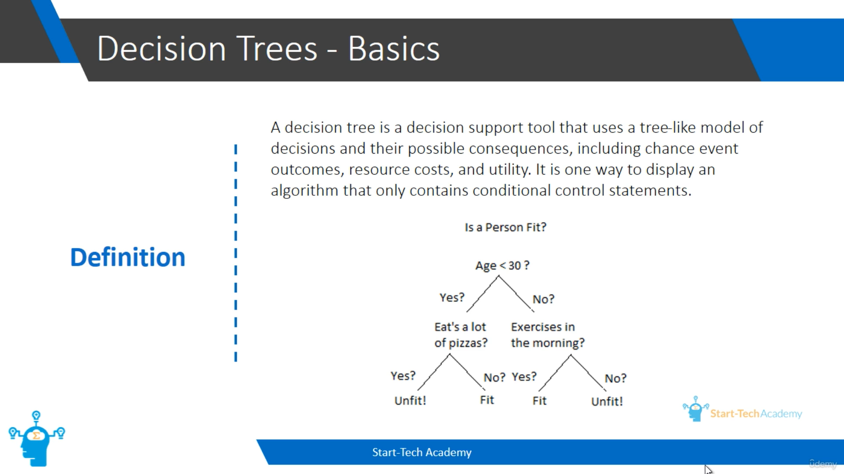
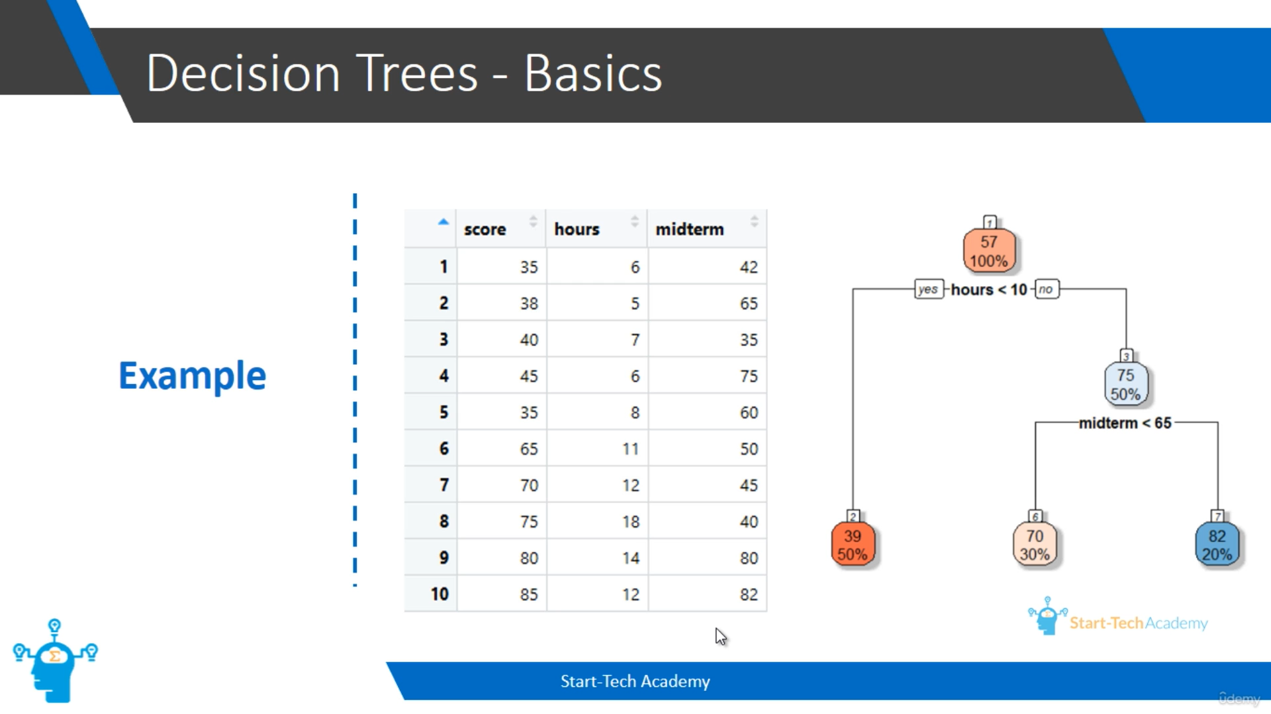
In the above example, we can split the data using decision tree. Like, spending less than 10 hours, we are having 50% of population and their average marks are 39 and spending more than 10 hours, we are having 50% population and their average marks are 75. Then onto further splitting, spending more than 10 hours and having less than 65 marks in midterm, we are having 30% population and their average marks are 70. Likewise, we can split the other possibility. This decision tree gives the overview that spending more than 10 hours and got more than 65 marks in midterm will give you more score.
TWO TYPES OF TREES:
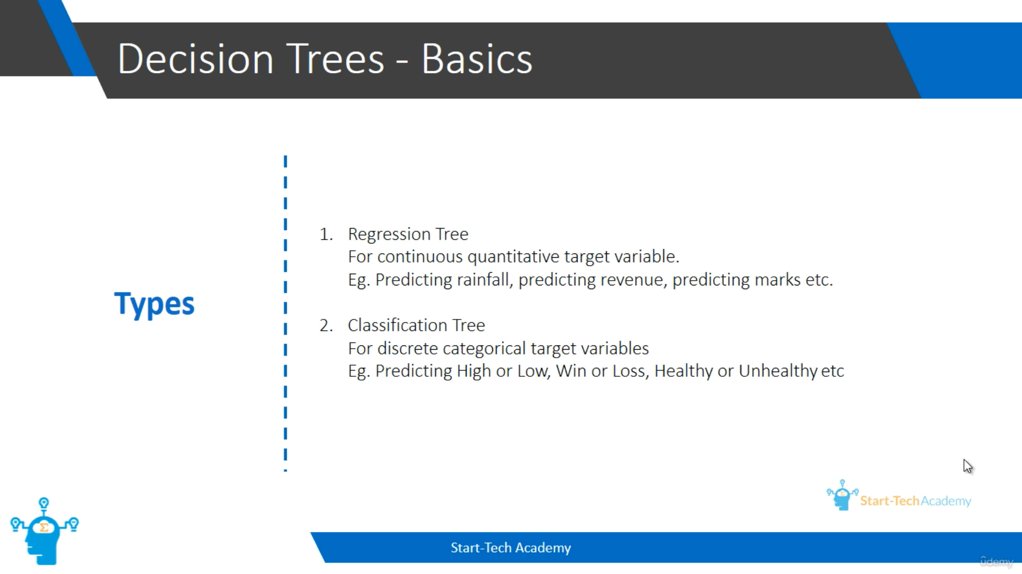
TERMINOLOGIES:
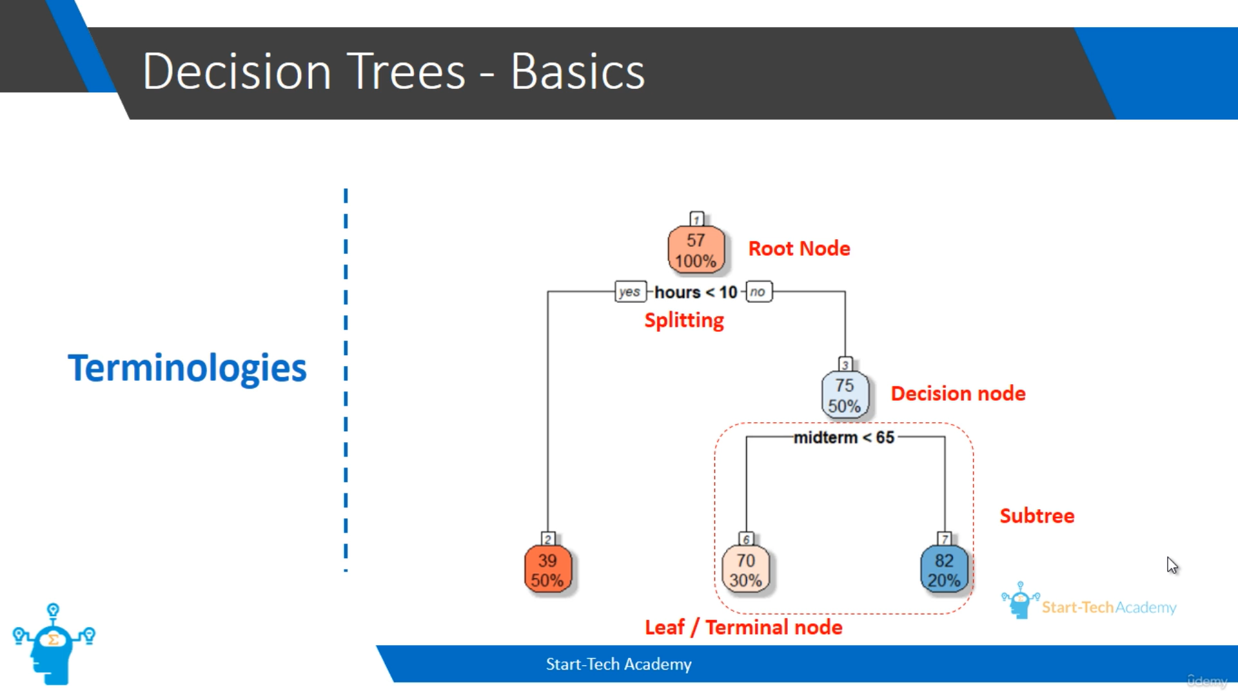

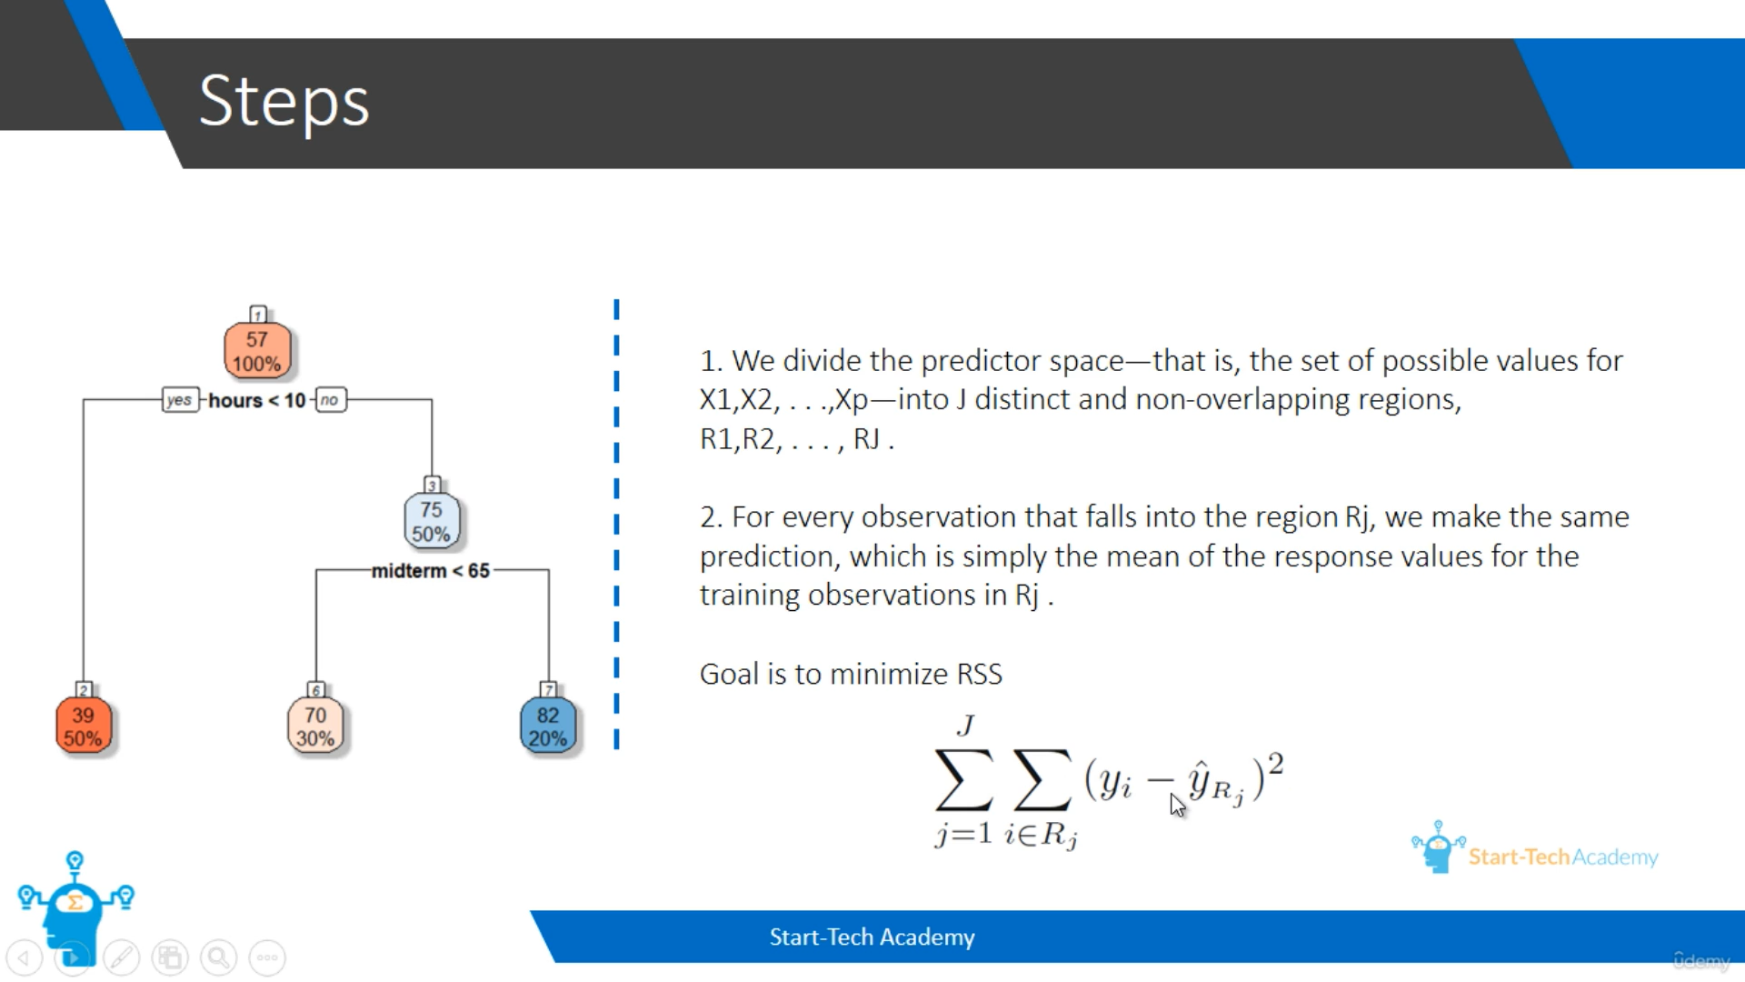
The variable and splitting value will be chosen such that value of RSS term minimum.
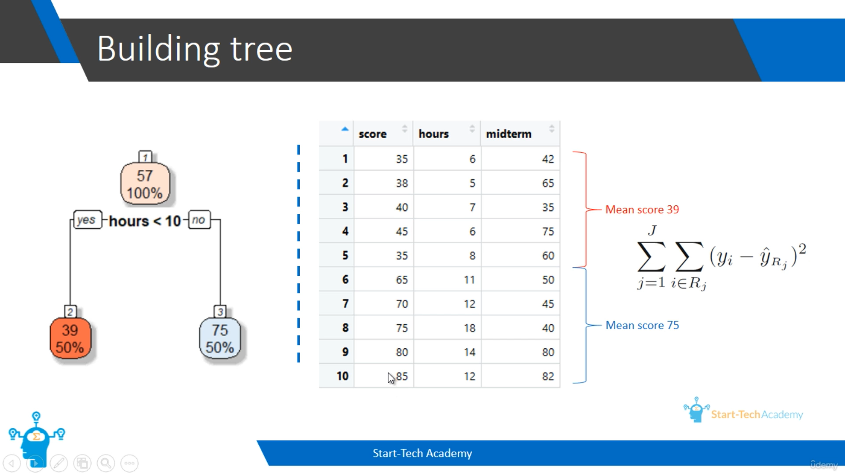
Here, the mean score for first split is 39. So, the RSS will be calculated like (35-39)^2 + (38-39)^2 + (40-39)^2 + (45-39)^2 + (35-39)^2. If we do the split like less than 15 hours, then the mean score wil vary and the RSS also vary. So, we make sure which split has the minimum RSS and chose the split.
